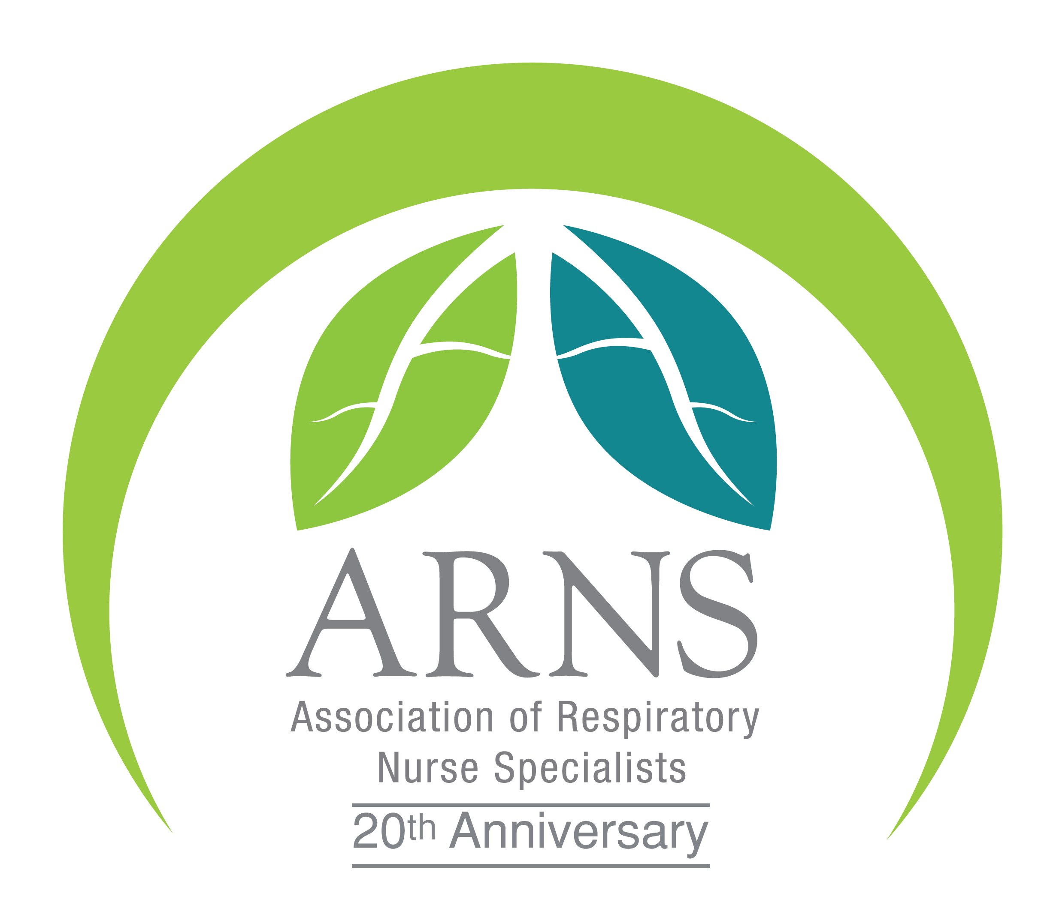

ARNS 20th Anniversary Conference

Celebrating 20 Years of ARNS – Roaring into the future

Friday 5th and Saturday 6th May 2017

Holywell Park, Loughborough

CONFERENCE BROCHURE 2017

Welcome to the ARNS 20th Anniversary Conference

On behalf of the ARNS Executive Committee, it gives me great pleasure again to welcome delegates, corporate partners, exhibitors and our charity partners to our 2017 ARNS conference as we celebrate in our 20th year as an Association.

After a very successful conference held at Loughborough University in 2016 the Executive Committee have again worked tremendously hard to offer an exciting and fresh agenda this year, which has been recognised by the RCN and been awarded RCN accreditation for the first time.

This is an exceptional Year for ARNS as we celebrate 20 years since the founders Chris Fehrenbach, Geoff Higgs and other committee members brought together the Association which has gone from strength to strength, embracing technology and communicating and engaging with our members through social media and our website. The ARNS Annual Conference remains at the heart of our work, and is still the only conference specifically organised by nurses, for nurses specialising in respiratory care. By focusing on such a specific peer group, we have been able to tailor our content so that it is fresh and relevant to enable debate, conversation and continued professional learning, as well as creating the right environment to learn & network.

I recognise that respiratory nurses continue to face a whole range of organisational challenges, assuring not only our specialist knowledge is updated, but also recognising the need to focus on the wider integrated approach to care and its justification. I am confident that this 2017 conference programme aims to reflect on a range of these challenges and opportunities facing us all today and in the future. I am delighted that this year we are able to welcome the Chief Executive Officer of the Royal College of Nursing Janet Davies, who I know personally is passionate and committed to articulating the views of Nursing and specialist nurses in a strong way.

In our 20th year there is further development and opportunities in (Sustainability and Transformation Plans (STPs), which offer us an opportunity to share and innovate and I hope you will all leave the conference feeling inspired and motivated, to continue making a difference to the patients and their carers we provide compassionate care too.

The ARNS annual conference is a fantastic opportunity to network and make new friends and please ensure your share your vision and get your questions answered and most importantly, engage in the exciting new possibilities open to nurses working within respiratory care across the UK having fun along the way.

Finally, I would like to take this opportunity to thank our corporate partners and to the dedicated nurses on the Executive Committee of ARNS. As I step down from ARNS chair and the committee, I am left with very fond memories and know exactly the passion and dedication of the committee members who have lead ARNS now and over the past 20 years. ARNS is a big inclusive family of all our professions and I recognise the vast amount of talent and commitment delivered by our members and the difference everyone makes to patient care, in these particularly difficult times, I am truly thankful as without your support and dedication to patient care none of this would be possible without you.

Warm regards for a fantastic 2017 conference


Dr Matthew Hodson, MBE
Chair, ARNS Executive Committee

 Don’t’ forget to follow us on Twitter during the conference @arns_uk #ARNS2017
Friday 5th May 2017

Chair’s Welcome
Dr Matthew Hodson, MBE,

Dr Matthew Hodson MBE
Chair ARNS 2015 - Present

Dr Matthew Hodson is currently the Chief Nurse at Virgin Care and also holds an Honorary Respiratory Nurse Consultant at the Homerton University Hospital London. He is current responsibility for the professional standards and leadership of nursing across the organisation. He previously managed an award winning integrated COPD team covering all aspects of management including hospital at home, PR and a home oxygen service.

Matthew completed his MSc in nursing at City University, where he is also an Honorary Senior Lecturer and completed his Professional Doctorate in Nursing, supporting the development of the COPD PREM-9. His main interests are research professional & advanced nursing practice along with his continued respiratory interest in COPD care, patient experience, education, oxygen therapy and advanced disease management in acute and primary care. Matthew has had a number of specialist roles across both primary and secondary care. Matthew is also a Council member of the Royal College of Nursing and the BTS Nurse Advisory Group. He won the Nursing Standard/RCN Nurse of the Year in 2013, for work around end of life care for people with advanced COPD. He has a passion for the patient experience and clinical leadership. Matthew recently completed the Nye Bevan leadership programme for inspiring directors. Matthew received an MBE for respiratory care in the 2015 New Year's Honours awards.

He commenced his term in office as Chair of ARNS in May 2015 and steps down in May 2017.
A Severe Asthma Service

Keynote Speaker

Janet Davies

Janet Davies is the Chief Executive and General Secretary for the Royal College of Nursing. The Royal College of Nursing (RCN) is the voice of nursing across the UK and the largest professional union of nursing staff in the world. The RCN promotes patient and nursing interests on a wide range of issues by working closely with the Government, the UK parliaments and other national and European political institutions, trade unions, professional bodies and voluntary organisations.
The key priorities for the Royal College of Nursing are to represent nurses and nursing, promoting excellence in professional and Trade Union practices and help to shape health and social care policies.

Prior to this appointment, Janet was one of the Executive Director’s at the Royal College of Nursing (joining in September 2005) and had the strategic lead for nursing and service delivery to its members.

Previous to joining the RCN, she had a long career as a Nurse within the NHS. She was Director of Nursing in West Lancashire and Liverpool and Chief Executive of Mersey Regional Ambulance Service.

Janet holds a BSc (Hons) Degree and MBA. She is a qualified RGN & RMN and a Fellow of the RCN.

Nursing Times Winner 2016

Sharon Stothard
A patient centered specialist asthma clinic for people with learning difficulties
Chest Clinic Manager, Sunderland

The presentation is about providing a patient centred specialist Asthma clinic for people with Learning disabilities. There are a number of patients who are known the LD team who frequently attend Asthma review clinics in Chest Clinic. Routine appointments are only 10 minutes long and this group of patients needed much longer also although they are a relatively small number of people they are extremely high users of out of hours services. High anxiety levers and lower levels of understanding and literacy meant that work was needed to improve compliance, reduce use of emergency services and empower this group of patients to feel in control of their asthma.

Sister Sharon Stothard, RGN, BSc (Nursing) MSc

I have been working in respiratory medicine for over 20 years, initially as a Junior sister on the Respiratory ward and for the last 17years as the Chest Clinic Manager and Respiratory Nurse Specialist.
I have a varied role including looking after COPD, OSA, Asthma and Tb patients. I run a nurse led severe Asthma clinic.
In 2016 I won the nursing Times Respiratory Nursing award for my work with patient’s who have asthma and learning disabilities.
I have eat, drink and breath ….. literally all things respiratory and I am sadly excited about inhaler devices!!

GSK Sponsored Symposium
The Salford Lung Study (SLS) in COPD: Relevance for your patients

Presented by Jill Leyshon and Allan Ullman

Jill Leyshon

Jill works for GlaxoSmithKline as a Medical Scientific Liaison (MSL), working with Healthcare Professionals to reactively address respiratory clinical questions and support their medical information needs. She is a registered nurse who has recently returned to practice, working on a Respiratory ward. Jill had a varied nursing career prior to joining GSK in 2000. In her last role she was a Practice Nurse with a particular interest in Asthma.

Jill started work with GSK in 2000 and held a variety of roles including non-promotional advisor roles in Respiratory, Smoking Cessation & Diabetes and then in Specialist Sales within Respiratory before being promoted to the role of Hospital Business Manager. For the last 4 years Jill has been part of the GSK medical team, in the non-promotional Respiratory MSL role. First in Yorkshire and now in the South West

Allan Ullman

Allan Ullmann works for GlaxoSmithKline as a Medical Scientific Liaison (MSL). He is a registered nurse with an Intensive Care background. Allan worked at Saint Thomas’ Hospital London before moving to the Regional Intensive Care Unit at Belfast’s Royal Victoria Hospital. GSK release Allan for a clinical session per week to work with NHS colleagues at the tertiary Regional Respiratory Centre in Belfast.

Allan started work with GSK in 2003, initially in primary care sales. In 2007 he was promoted to Area Manager for Northern Ireland.

In 2013, he took on the non-promotional Respiratory MSL role. Here, he works with HCPs to reactively address respiratory clinical questions and support their medical information needs.

Breakout Sessions

Principles of Chest Auscultation/Chest Xray

Wendy Preston
Head of Nursing Practice, RCN and Honorary Respiratory Nurse Consultant

Natalie Harper
Respiratory Advance Nurse Practitioner, Dorset County Hospital Foundation Trust
A practical and interactive session running through how to undertake a full chest examination, including chest sounds to be aware of. Some common clinical signs will be discussed and how these may influence management plan and diagnosis. The systematic review of chest x-rays will be discussed and how to structure your decision making. Please note that participation in this session does not deem you competent to perform chest examinations in practice.

Wendy Preston

Head of Nursing Practice at the RCN: Since qualifying as RGN in 1992 Wendy has continued studies, achieving MSc in Respiratory Care with post graduate certificates in prescribing and higher education and practices clinically as an Advanced Nurse Practitioner and Honorary Respiratory Nurse Consultant.

Previous teams include Nursing Times ‘Team of the Year’ 2014 (acute medical unit/ ambulatory care) and Senior Lecturer at Coventry University. She is involved with policy and clinical practice leadership at a national and international level and co-edited a respiratory book published in 2016. Her work was acknowledged in 2014 by being recognised as an HSJ Rising Star. Wendy is the current Vice-Chair of ARNS and a board member of ERNA & ESNO.

Natalie Harper

I originally trained in Suffolk from 1988-1990 as an Enrolled Nurse and then subsequently converted to a Registered Nurse. I worked as a Practice Nurse for 19 years with a passion in Respiratory medicine before returning to secondary care as a Respiratory Nurse Specialist in 2009. Since then I have continued to maintain strong links with both primary and secondary care and I have been involved in the setting up of some respiratory services across Dorset. As an independent non-medical prescriber I now run nurse led respiratory clinics in 3 community hospitals and an acute hospital covering a range of respiratory conditions. I am always fully aware of the challenges and problems that patients, carers and staff face on a daily basis and strongly believe that working within a large multidisciplinary team benefits everyone involved.

I joined Education for Health as a Regional Trainer in 2009 with a desire to improve patient care and enhance the skill levels of fellow health professionals’, after previous experience of being a student with Education for Health, completing the Asthma diploma in 1995 and subsequently completing my BSc Hons in Respiratory Care in 2012. I continued along the education path and subsequently completed my MSc in advanced practice in 2016 with a view to starting a doctorate next year as I strongly believe that education makes a significant difference.

I was honoured to become the first secondary care nurse in the UK to be badged by the British Lung Foundation in 2011. In 2012 I was involved in the National Review of Asthma Deaths led by The Royal College of Physicians. I maintain personal membership of the British Thoracic Society, the European Respiratory Society and The Association of Respiratory Nurse Specialists, where I joined the executive committee in September 2013. I act as a nurse advisor on the Wessex AHSN and have acted as a visiting lecturer at Bournemouth University. My most recent appointment was with Asthma UKs Council of Healthcare Professionals.

Oxygen in the acute setting – case studies

Elaine Jackson
Respiratory Nurse Specialist, Northern Ireland

Elaine’s presentation today relates to acute oxygen therapy case studies aiming to demonstrate issues and responsibilities in administering oxygen

Elaine Jackson

Elaine has been a Respiratory Nurse Specialist in the South Eastern Trust for 16 years. She works mainly in the acute setting, but also in Nurse/Physiotherapy Led Clinics in oxygen, bronchiectasis, COPD and asthma. Her current interest is in Interstitial Lung Disease and acute NIV, currently undertaking a quality and improvement project (SQE: Safety, Quality and Experience) to improve standards in NIV. She has also recently expanded her role to include a Respiratory HUB with the aim of discharging patients quicker from hospital with Respiratory input and turning patients round in A&E. The HUB also has a role in rapid access from community sources and within the hospital. She is on the committee of ARNS just having completed 3 years in that role.

Oxygen in the Community (Case Studies) – an in-depth look into the lives of 2 patients living with oxygen

Gail McKeown
Clinical Specialist Respiratory Physiotherapist

Gail McKeown is an Advanced Practitioner in the respiratory service in the South Eastern Trust in Northern Ireland, currently based in the Downe Hospital. Gail has been a respiratory specialist physiotherapist for the SET for 11 years. Gail is an non-medical prescriber and associate lecturer to physiotherapy undergraduates at the University of Ulster Jordanstown. Currently Gail runs the Home Oxygen Service for Assessment and Review (HOSAR) service at the Downe Hospital. Gail also runs a Bronchiectasis service and Pulmonary rehab service in the Downe community and is the Community Respiratory Physiotherapy Team lead in the Downe community.

Breakout Sessions

Acute NIV Case Studies

Samantha Prigmore
Nurse Consultant, St George’s Hospital, London

In this interactive workshop, the principles of acute respiratory failure and how ventilators work will be briefly discussed. Case studies will be used to demonstrate the management of acute acidotic respiratory failure in different conditions, from admission through to discharge planning.

Articles and Books of interest

BTS /ICS (2016) Guidelines for the ventilator management of cute hypercapnic respiratory failure in adults
Thorax 71 Sppl 2

Elliott M, et al (2002)Where to perform noninvasive ventilation?
Eur Respir J 19:1159-1166

Elliot M (2005) Non Invasive Ventilation in acute exacerbation sof COPD
Eur Respir Rev 14: 39-42

Gray A, et al on behalf of the 3CPO triallists. (2008) Non invasive ventilation in acute cardiogenic pulmonary edema.
N Engl J Med:359;142-151.

Kinnear W J (2007) Non-Invasive Ventilation Made Simple
Nottingham University Press, Nottingham

NICE (2016) Motor Neurone Disease; Assessment and management (NG42)
www.nice.org.uk/guidance/ng42
Plant P et al (2000) Early use of non-invasive ventilation for acute exacerbations of chronic obstructive pulmonary disease on general respiratory wards: a multicentre randomised controlled trial.
Lancet; 355: 1931–1935

Simmonds A (2007) Non-Invasive Respiratory Support A Practical Handbook (3rd Edition)
Hodder Arnold, London
Wildman M et al (2009) Survival and quality of life for patients with COPD or asthma admitted to intensive care in a UK multi-centre cohort: the COPD and Asthma Outcome Study (CAOS) Thorax 64(2) 128- 132
Sam Prigmore has specialised in cardio respiratory nursing in since qualifying over 25 years ago, and was one of the first respiratory nurse specialist to be appointed In the UK.

She is passionate about providing holistic care for people with respiratory disease and has been instrumental in developing respiratory nursing teams in the both the acute and community setting. She has extensive experience in nursing patients with asthma (in particular, severe and difficult asthma, transitional services and asthma in pregnancy), COPD and patients requiring ventilatory support.

She has worked closely with CCG’s to develop and redesign respiratory services and nationally has been part of the National Clinical Strategy for COPD and Asthma.
She is actively involved in the British Thoracic Society, representing nursing on several committees, Primary Care Respiratory Society- UK and Association of Respiratory Nurse Specialists (previous Chair). Sam has worked closely with respiratory charities, and was a Trustee for the British Lung Foundation for 7 years. She is a trainer for Education for Health
She is currently studying for a PhD in Nursing at the University of Manchester. She is developing a respiratory nurse sensitive outcome indicator tool to measure the impact that respiratory nurse specialists have on patients experience of living with COPD.

Breakout Sessions

Community NIV Case Studies

Claire Stewart
NIV Specialist Nurse, Northern Ireland

AIMS AND OBJECTIVES

The use of home mechanical ventilation in patients with chronic respiratory failure has increased dramatically over the last 20-30 years, largely as a result of the result of using portable and user-friendly non- invasive ventilators and improved interfaces.
The evidence base for long term application is less well established than that for acute use. Use in stable chest wall disease and neuromuscular conditions produces good results.
The goals of home ventilation is to:
- Extend life
- Enhance quality of life
- Reduce morbidity
- Improve physical and physiological function
- Deliver treatment safely and cost effectively
This presentation will focus on some of the challenges faced with community NIV provision.

Respiratory Nursing Mastermind
Past Chairs of the Association of Respiratory Nurse Specialists

Chris Fehrenbach
Chris Fehrenbach trained in the RAF then followed a career in Respiratory medicine both in primary and secondary care.
She has been a trainer for Education for Health .

She was the first nurse to be elected to the BTS Council and worked on the education committee. She was the founder member and Chair of ARNS.

She has been a member of the BLF council and now is the Honorary Nurse Advisor.

She founded the BLF nurse scheme.

She now enjoys semi retirement still working in primary care and respiratory research Her main interests being helping people with difficult asthma and COPD. She now enjoys life in her garden, travelling the world but most important her husband ,children, and grandchildren.

Linda Pearce
Dr Linda Pearce is a Respiratory Consultant Nurse at West Suffolk NHS Foundation Trust. Her interest in respiratory health started as an occupational health nurse and progressed through practice nursing. She completed her Doctorate in Nursing at Essex University. Her thesis looked at non drug management of breathlessness in COPD. She sits on various advisory boards/committees, is a member of the SIGN/BTS Evidence Review Group for pharmacological management of asthma and is a Visiting Fellow for Essex University.

Samantha Prigmore
Sam has specialised in cardio respiratory nursing in since qualifying over 25 years ago, and was one of the first respiratory nurse specialist to be appointed In the UK.

She is passionate about providing holistic care for people with respiratory disease and has been instrumental in developing respiratory nursing teams in the both the acute and community setting. She has extensive experience in nursing patients with asthma (in particular, severe and difficult asthma, transitional services and asthma in pregnancy), COPD and patients requiring ventilatory support.

She has worked closely with CCG’s to develop and redesign respiratory services and nationally has been part of the National Clinical Strategy for COPD and Asthma.
She is actively involved in the British Thoracic Society, representing nursing on several committees, Primary Care Respiratory Society- UK and Association of Respiratory Nurse Specialists (previous Chair). Sam has worked closely with respiratory charities, and was a Trustee for the British Lung Foundation for 7 years. She is a trainer for Education for Health
She is currently studying for a PhD in Nursing at the University of Manchester. She is developing a respiratory nurse sensitive outcome indicator tool to measure the impact that respiratory nurse specialists have on patients experience of living with COPD.
Joanne Riley

Jo is the Lead Respiratory Nurse for Oxford Health NHS Foundation trust, leading a county wide service mainly for patients with COPD including prevention of admission, early discharge, pulmonary rehabilitation and home oxygen assessment and review services. The integrated service has been in existence in its current set up for the past 7 years but is the result of an evolving service that has been running under Jo’s leadership for the past 15 years.

Jo has been working in respiratory medicine for almost 28 of her 33 years of nursing. During that time Jo had managed respiratory wards and been responsible for developing new services and new ways of working. Jo has also been a member of the DoH Home oxygen user group and has had involvement with the development of the COPD and Asthma Clinical Strategy.

Jo was the Chair of the Association of Respiratory Specialist Nurses from 2011 - 2013 after having been a member for the previous 7 years. Jo was also part of the original committee of ARNS, holding the post of treasurer at that time. She is also a member of the BTS, PCRS and ERS.

Jo is passionate about patients receiving the highest quality care at all times. She is involved in local guideline groups for Asthma and COPD, and runs educational meetings for all HCP’s involved in managing patients with airways diseases in order to ensure high standards of knowledge and integrated care for the patients.

Rebecca Sherrington
I am a qualified nurse who has over 20 years of experience working within a wide and varied service areas, although I have worked predominately in cardiac and respiratory care. I was recently a respiratory nurse consultant on Guernsey, providing expert specialist-nursing advice across all sectors and running nurse led clinics for a range of respiratory diseases. As a consultant nurse I provided national leadership and guidance on respiratory care (including working in collaboration with Public Health England), contributing to national guidelines, articles and publications. I provided written evidence to the All Parliamentary Party Group (APPG) Inquiry in to Respiratory Deaths (2014) and was a panel member on the Royal College of Physicians, asthma deaths inquiry (2013). I was also the former chair of ARNS 2013-2015 and won a Nursing Times leadership award in 2015.

More recently I have stepped out of specialist nursing, in to a service redesign role in Jersey and am now working across the whole system to provide integrated Health and Social Care. I am the lead on a number of projects which support out of hospital service redesign and commissioning; which requires service redesign, planning and leadership skills. The role is to design and test new ways of working, new roles, new service models, pathways and new ways of progressing the strategic agenda. As a registered nurse I continue to collaborate with a network of significant professional contacts to ensure that my practice remains cutting edge and current, supports best practice and remains evidence based for care services within Jersey.

Jenny Till
Now retired from her nursing career Jenny is busy with life on the Isle of Skye; her next project being a self-build house that she designed a few years ago. Up until 2011 Jenny spent 20 years specialising in Respiratory Nursing and since her move to Skye she worked in Practice Nursing again for over five years.

Clinical Lead - South Lakes Community Respiratory Service 2007 – 2011
Community RNS – NHS Cumbria 2002 – 2007
Respiratory NP – Royal Lancaster Infirmary 1996 – 2002
Practice Nurse 1989 - 1996

Senior Lecturer (Nurse Practitioner Programme) 2001 – 2003
National Trainer for Education for Health 1991 - 2011

ARNS Committee: Vice Treasurer 1997 – 2001
ARNS Committee: Website Co-ordinator 2003 – 2006
Vice Chair 2006 – 2008
Chair 2008 – 2010

Elizabeth Walker
Liz has been a Respiratory Nurse Specialist for 23 years, specialising in NIV, Respiratory Failure, COPD and Sleep. Liz is currently Lead Nurse for Respiratory at Queen Alexandra Hospital in Portsmouth where she also manages the Sleep and Ventilation Services. An aspect of this role that Liz finds particularly interesting is the way in which COPD, obesity and sleep medicine are constantly overlapping. Liz is also interested in palliative care for respiratory and neuro muscular patients.

Liz’s past experience encompasses close involvement with ARNS where she was chairperson from 2003 – 2005. Liz was also on the British Thoracic Society Education Committee. She has also represented ARNS on the Department of Health ‘OSA Service Specification Review’.

In her spare time Liz enjoys being very active playing squash, mountain biking and paddle boarding. She is, in fact, attempting Tough Mudder on Sunday – she is not sure she is looking forward to it!!!

Saturday, 6th May 2017

Boehringer-Ingelheim Sponsored Symposium

Clinical Options in Context of the GOLD Guidelines

Jane Scullion
Nurse Consultant, Glenfield Hospital, Leicester

Jane is currently a Respiratory Nurse Consultant at the University Hospitals of Leicester and Respiratory Clinical Lead for the East Midlands working with the AHSN and the SCN. She is a Trustee at PCRS-UK and during her spare time is amongst other things, a course team member and tutor for the University of South Wales, Regional Chair for the BLF, NICE advisor for the RCN and an Expert nurse in medical negligence cases and banks as a custody nurse for the police.

Vice Chair’s Introduction and poster prize giving

Wendy Preston
Head of Nursing Practice, RCN and Honorary Respiratory Nurse Consultant

Head of Nursing Practice at the RCN: Since qualifying as RGN in 1992 Wendy has continued studies, achieving MSc in Respiratory Care with post graduate certificates in prescribing and higher education and practices clinically as an Advanced Nurse Practitioner and Honorary Respiratory Nurse Consultant.

Previous teams include Nursing Times ‘Team of the Year’ 2014 (acute medical unit/ ambulatory care) and Senior Lecturer at Coventry University. She is involved with policy and clinical practice leadership at a national and international level and co-edited a respiratory book published in 2016. Her work was acknowledged in 2014 by being recognised as an HSJ Rising Star. Wendy is the current Vice-Chair of ARNS and a board member of ERNA & ESNO.

Paediatric Sessions

The Management of Children & Young People in the Difficult Asthma Service in Sheffield

Anita Critchlow
Respiratory Nurse Specialist, Sheffield Children’s Hospital

My presentation looks at the approach of managing children and young people in the Difficult Asthma Service in Sheffield. This approach is different to adults as it involves home visits and school visits to assess factors that may be contributing to their uncontrolled asthma symptoms. Safe-guarding is often a consideration with these difficult asthma patients particularly with non-adherence to treatment and risk-taking. Transition also plays a big part especially in encouraging parents to relinquish their responsibility to their child.

Anita Critchlow

Anita has been a Paediatric Respiratory Nurse Specialist for 16 years working at the Sheffield Children’s NHS Foundation Trust. She has a degree in Respiratory Paediatric Specialist Nursing Practice and recently become an MSc Advanced Paediatric Nurse Practitioner.

Anita manages weekly nurse-led clinics reviewing general respiratory, allergy and difficult asthma patients. She has a special interest in difficult asthma and is part of the Difficult Asthma Clinic which enables more dedicated time for in depth assessment as often other factors like adherence, family circumstances can contribute to their ongoing symptoms.

She has been a committee member on the National Paediatric Respiratory and Allergy Nurses Group for the last 8 years and is currently the Chair. She also is a committee member of the Severe Asthma National Network.

The UK Respiratory Research Nurse Consortium

Dr Carol Kelly
Senior Lecturer, Edge Hill University

Carol will present an overview of the RNRC (Respiratory Research Nursing Consortium) from its inception, outlining the key aims, objectives and vision. The presentation will include the key findings from a recent UK wide Delphi survey, which identified top research priorities for respiratory nurses, and the forthcoming ARNS research strategy. The RNRC is a collaborative venture between ARNS and the Postgraduate Medical Institute (PGMI), Edge Hill University, Lancashire. Carol will share the steering group’s thoughts for future development of the consortium, but will also be keen to hear the views of ARNS members.

Carol Kelly

Carol Kelly qualified as a registered nurse in 1983, she worked as a Respiratory Nurse Specialist and held senior clinical roles for several years. Based in higher education since 2003, Carol is currently Head of Applied Health & Social Care in the Faculty of Health & Social Care at Edge Hill University (EHU), Lancashire. Carol was awarded a PhD in 2014 for her work exploring perceptions of oxygen therapy from both patients’ and healthcare professionals’ perspectives. Her research interests concern respiratory care, in particular the needs and care provided to respiratory patients, and the impact that training, education and knowledge have on the provision and quality of that care. She has published widely on respiratory topics. Carol’s current research projects include: the prevalence of respiratory symptoms and diagnoses in a UK prison; models of self-management for bronchiectasis patients; developing and testing an integrated care pathway for bronchiectasis; and identification of national research priorities for respiratory nursing. Carol is currently undertaking two Cochrane reviews concerning antibiotic use and self-management in bronchiectasis, and was member of the BTS (British Thoracic Society) Emergency Oxygen Guidelines Group, collaborating on the forthcoming update of the BTS Emergency Oxygen Guidelines. As a previous member of the Association of Respiratory Nurse Specialists (ARNS) Executive Committee, she continues to collaborate on several projects and is a keen advocate for respiratory nursing. She is Chair of the RNRC (Respiratory Nurse Research Consortium), a collaborative venture between ARNS (Association of Respiratory Nurse Specialists) & the Postgraduate Medical Institute (PGMI) at EHU, and has recently co-edited a book: Preston W and Kelly C (2016) Respiratory Nursing at a Glance. Chichester: Wiley.

Research – The patient experience in a research Study

Bill Green

Dr Mo Al-Aloul
Consultant Respiratory and Transplant Physician, Honorary Senior Lecturer,
Manchester University

Update on Lung Transplantation

Objectives: the audience will gain understanding of

- Who, when and why patients are listed for transplantation
- Contraindications to organ allocation
- The changing landscape of organ allocation in the UK
- Challenges of life after transplantation

Dr Mo Al-Aloul

Dr Al-Aloul completed undergraduate studies at Dundee University and specialist training in respiratory medicine in the Mersey Deanery. He was awarded an MD for his research into antibiotic toxicity in the treatment of Pseudomonas aeruginosa lung infection in Cystic Fibrosis.

He was appointed to his current post at University Hospital of south Manchester in 2005 and is now the lead lung transplant physician, a core member of the lung cancer MDT, a member of the specialist pleural team and is helping to set up a regional advanced emphysema service encompassing pharmacological, endobronchial, surgical lung volume reduction and transplant interventions. He is a bronchoscopist, a thoracoscopist and a thoracic ultrasonographist, amongst other skills. He is keen to strengthen integration with primary care and a strong supporter of the model of hospital outreach to deliver specialist services in the community.

Dr Al-Aloul is founder and past chair (2006 – 2013) of the Association of Lung transplant Physicians (ALTP-UK) and was appointed chair of the Lung Allocation Working Party for NHSBT in 2012; his group has developed a new clinical need centred organ allocation system ensuring equity and transparency. His research interests revolve around bugs and toxic drugs. He enjoys undergraduate and postgraduate teaching and welcomes the opportunities offered by events, such as today’s, to meet his colleagues around the country.

Keynote Closing Speakers

Celebrate 20 Years of ARNS

Gail Miles
Nurse Consultant, Rotherham

Dr Jon Miles
Consultant Chest Physician, Rotherham

Gail Miles

Gail is the Coalfields Regeneration Trust Respiratory Nurse Consultant and Lead Clinician at BreathingSpace. This unique institution for delivering nurse-led care celebrates its 10th anniversary this year and has been rewarded with a CQC commendation of outstanding care following a recent inspection. Over the coming 18 months Gail will be focussing on extracting the 10 years worth of clinical data from the patient records at BreathingSpace and looking to publish the findings. She is also working with the Coalfields to generate a robust health economic model for the care delivered at BreathingSpace.

Jon Miles

Jon is a Consultant Chest Physician and Divisional Director for integrated medicine at Rotherham Foundation Trust. He also leads on the Respiratory Component of the Longterm Conditions MSc at Sheffield University. He gave a keynote speech at the very first ARNS Conference and has been an advocate of the organisation ever since. He regards it as a privilege to be invited back to join in the 20th celebrations despite the obvious reminder of how old he is now!

Poster abstracts

Abstract Full Title: Nurse Led diagnosis and management of NIV in the acute setting

Author(s): Gail Miles, Tara Ingles, Lisa Hatfield, Tracy Ward
Address: BreathingSpace, Rotherham, Yorkshire

Please Detail your abstract (up to 350 words) below:
Title, aims/ objectives, methods (innovation, or service process change), findings / results/ Summary.
Aims/ Objectives:

BreathingSpace is a unique nurse led facility in Rotherham which as well as an extensive outpatient and pulmonary rehabilitation programme has a 20 bedded inpatient unit looking after patients with acute exacerbations of respiratory disease. The unit receives direct admissions from a variety of sources including direct paramedic admission.
Our aim was to assess if the diagnosis and management of Acute Hypercapnic Respiratory Failure (AHRF) can be managed safely in its entirety by nurses. We present the outcomes of the initiation and management of NIV in our nurse led unit with no high dependency facility on site. There was no medical input into the management at any stage.

Methods (detail of innovation or service process/change):

A review of the computerised medical records of all patients identified as having AHRF on the inpatient unit of BS between Jan 2015 and Jan 2017. Data was collected using the British Thoracic Society (BTS) NIV audit data tool. This includes diagnosis, blood gas measurements at various time points and outcomes.
Findings/results:

46 patients 26 (56%) female Mean Age 72 (range 46-88)
42 (91%) COPD - mean FEV1 40% pred (range 11-76)
Spirometry recorded in the last 2 years: 37 (80%)
Initial Blood Gas: all patients had a pH <7.35 following initial management (6 patients had pH <7.25)
Only 2 patients (4%) were transferred to the local hospital for medical assessment. The remaining patients were managed to discharge (or death) entirely by nurses.
Survival to discharge: 40 (87%)
Of the 6 deaths 5 were managed entirely at BS.
Summary/ Conclusion/ Recommendations for practice

Although traditionally a medical led diagnosis and treatment, with nurse and/or therapist assistance we have demonstrated that AHRF can be safely diagnosed and managed in its entirety by appropriately trained nurses. This has implications for the future development of stand alone nurse led units.

Abstract Full Title: Ensuring patients receive a 48 hour follow-up review post discharge from hospital with exacerbation of asthma in line with NRAD Recommendations

Author(s): Angela Blundell
Address: Lister Hospital, East & North Herts, Corey’s Mill Lane, Stevenage, SG1 4AB

Aims/ Objectives: To ensure a 48 hour review provided by a Respiratory Clinical Nurse Specialist following hospital attendance or admission for exacerbation of asthma; in line with NRAD 2010 recommendations. This was in order to prevent unnecessary mortality and improve patient compliance to treatment.

Methods (detail of innovation or service process/change): Following verbal feedback from patients stating they were unable to receive a 48 hour review from their GP we were able to implement an ad-hoc 48 hour nurse led follow up. We were able to provide these 5 days per week due to the expanding chest team service at the Lister Hospital. This review included clinical tests and education as well as medication and inhaler review. These clinics improved patient pathway and allowed direct referral s into specialist asthma and allergy services if indicated. Alternatively the patient was referred back to the GP Practice with a management plan in place which also improved integration between services.

Findings/results: A quarterly review from October 2016 - December 2016 showed on average 27 patients per month were admitted with an acute exacerbation to the Lister hospital. In October 2016, 20 patients were admitted to the Lister with an acute exacerbation of asthma.
* 12 (60%) of the 20 patients received a 48hr follow up review in our nurse led clinic.
* 4 (20%) of the 20 patients declined follow up.
* 3 (15%) of the 20 patients were cared for elsewhere or live out of area.
* 1 (5%) of the 20 patients did not receive a follow up review at the acute trust.
* The DNA rate for October 2016 was 0%.
Summary/ Conclusion/ Recommendations for practice: Although currently we are aiming to provide all asthmatic patients admitted to hospital a 48 hour follow up; our future aim is to review all asthmatic patients who have attended the Emergency Department not requiring admission. These patients were often referred to the ambulatory care service within the Trust therefore we will need to work closely with both departments to meet this objective. Finally in the near future we hope to obtain qualitative feedback of the service to ensure we are meeting our initial objectives, as well as undertaking an audit to look at re-admission rates within the trust.

Abstract Full Title: The use of FENO in stopping years of damage caused by oral steroids in Asthma.

Author(s): C Roxas, D J Jackson
Address: Guy’s & St. Thomas’ NHS Foundation Trust
Guy’s Hospital. Chest Clinic. 2nd Floor Bermondsey Wing. Great maze pond. SE1 9RT

Title: The use of FENO in stopping years of damage caused by oral steroids in Asthma.

Theme:
Historically the management of asthma has been reliant on the patient’s perception of their symptoms. Increasing inhaled corticosteroids and oral prednisolone doses, if they felt symptomatic with their breathing, which has left some patients on long-term oral prednisolone for many months and even years. Prednisolone is an anti-inflammatory medication, when used appropriately in the asthma population has clinical benefits. However, long-term use has associated side effects such as osteoporosis, weight gain and insomnia.

Our understanding of asthma has evolved as we start to learn about phenotypes and the use of measuring inflammatory biomarkers to guide treatment. Fractured exhaled nitric oxide (FENO) testing is routinely used in our asthma nurse led clinics as it provides an almost instant quantitative measurement of airway inflammation and a predictor of corticosteroid response.

Specific Learning from the reflection / case study:
The use of measuring FENO within the asthma nurse led clinic has enabled us to safely wean 5 patients off prednisolone, with 6 patients actively undergoing the weaning process and 1 patient requiring half the dose that was prescribed for approximately 4 years.

Some of these patients were on oral steroids for over a decade and as a result has developed side effects such as osteoporosis. Therefore, by decreasing unnecessary prednisolone use we have reduced the chances of further associated harm. In addition, it has empowered the patients to understand their asthma alongside clinical objective markers.

Implications for your practice and the wider respiratory nursing community:
All patient’s that are on long term steroids will be regularly reviewed in the asthma nurse led clinic, with the aim to safely taper their oral steroid dose to their minimum requirement and potentially stopped, through the use of measuring inflammatory biomarkers. The asthma nurse’s role is vital in this process; through clinical monitoring, education, making the patient feel safe and in control of their asthma management.

By incorporating this way of practice it will also ensure that our future patients are safely treated in an evidence based and individualised manner

Abstract Full Title: The ‘B’ Word: Enabling understanding and compassionate care through a language barrier.

Author(s): Emma Vincent (Interstitial Lung Disease Nurse) and Sue Mason (Head of Nursing)

Please Detail your abstract (up to 350 words) below:
Title, aims/ objectives, methods (innovation, or service process change), findings / results/ Summary.
Aims/ Objectives:

Background: Within my role I palliate interstitial lung disease (ILD) patients.
I address their physical, social, psychological and spiritual needs during their dying phase of their disease.
Breathlessness is one of the most common symptoms reported by my patients.
The management of this symptom is a large majority of my role and is documented within my service audit data as 60% of my time spent with patients (ILD Nurse Service Audit, 2016).
I currently have no written patient information to help aid the understanding of this frightening experience for those patients within the Asian and Indian communities, who do not speak English. No other patient information exists Nationally.
‘Breathlessness’ does not translate into the Hindu, Punjabi or Guajarati languages.

This abstract describes the service innovation, and the developmental work which will contribute towards the development of a culturally sensitive leaflet, (that may aid those who are breathless within the Asian and Indian communities of Leicester).
In addition, I will demonstrate the local and national drivers that provide supportive evidence for this innovation.

Aim: To empower Indian/Asian patients/carers to help me develop patient information for breathlessness that is meaningful to them.
I will consider:
*What I understand about the organisational culture that is enabling/inhibiting this?
*Equality of care, and compassion enablement.

Methods (detail of innovation or service process/change):

I conducted two (groups of six) focus groups with Indian patient and carers.
A SENSES Framework (Nolan et al, 2006) approach, combined with grounded theory (Charmaz, 2006) was used to explore the current patient and carer experience.
In addition, Appreciative Inquiry (Kessler, 2013) was implemented to discover:
Whether English compassion/ideals worked within the Indian culture?
What were their models and expectations of new patient information? And
Would a potential clash of culture be challenging within the development stage?

In order to consider the likely success of this project within my workplace, the King’s Cultural Assessment Tool (Kings, 2015) was used to evaluate potential themes of collaboration or conflict.

Findings/results:

Through the methodology the following was discovered:

Culture is multi faceted.
Complexity occurs within varied perspectives.
Ethnicity is embedded into language.
Meaningful change will need resilience.
Continual feedback during the development was desired.

Summary/ Conclusion/ Recommendations for practice:

At this stage, the developmental work is implying three critical questions:

1 | How can I learn from patient and carer feedback without resorting to blaming organisational culture, and/or producing over simplistic solutions?
2 | To what extent is compassion and equality required to aid patient experience?
3 | How will I lead on therapeutic change to aid equality and compassion through my patient’s language barrier?

Promoting equality is at the heart of my nursing values – ensuring fairness in all that I do is inclusive of avoiding the exclusion of patient groups. Over the next year I will continue to identify drivers, work internally, and in partnership with the varied stakeholders who may influence this project. I aim to lead advancing equality in palliative care, and to transform the patient’s overall experience by empowering their understanding of a frightening palliative symptom.

Abstract Full Title:

Outcomes from COPD hospital admissions in England

Author(s): Stone R, Holzhauer-Barrie J, Lowe D, McMillan V, Saleem Khan M, Searle L, Skipper E, Welham S.
Address: Royal College of Physicians, 11 St Andrews Place, Regents Park, London, NW1 4LE

Aims/ Objectives:
The National COPD Audit Programme collects data on the care of COPD patients in England and Wales. The programme ran a secondary care snapshot audit between February and April 2014, which aimed to capture all acute exacerbations of COPD admitted to hospitals in these nations. The records of 13414 patients were collected.

The audit aimed to understand the impact processes of care, captured in the clinical audit, had on patient outcomes (mortality, readmissions, and length of stay) and, subsequently, to identify areas where care could be improved.

Methods (detail of innovation or service process/change):
The audit obtained permission to collect patient identifiers which were used to link the English audit cohort records (n=12594) to externally available sources of outcome data. This included hospital admission data held by Hospital Episode Statistics, used to ascertain how often patients were readmitted within 30-90 days of the index admission and how frequently they had been admitted in the year prior to this. Audit data was also linked with national mortality data held by the Office of National Statistics. If feasible, comparisons were made against earlier audits.

Findings/results:
- Inpatient mortality has reduced historically (7.9% 2003, 7.8% 2008, 4.3% 2014)
- There has been a historical reduction in the median length of stay (6 days 2013, 5 days 2008, 4 days 2014)
- Within 30 days of discharge, 24% were readmitted at least one for any reason, and 12% of patients were readmitted at least once owing to COPD
- Within 90 days of discharge, 43% were readmitted at least once for any reason, and 23% of patients were readmitted at least once owing to COPD
- 36%, 51% and 65% of patients had at least one admission for any reason in the 90, 180 or 365 days prior to their index admission
- 19%, 27%, and 36% of patients had at least 1 COPD admission in the 90, 180 or 365 days prior to their index admission
- There was no relationship between readmission rates and length of stay.

Summary/ Conclusion/ Recommendations for practice

The audit data reveal there have been improvements in some patient outcomes; however, frequent readmissions stress the importance of good discharge planning and integration of care between sectors.

Abstract Full Title: “Being with” a patient at end of life
Author(s): Lucy Speakman

Theme: this poster is based around a case study of a patient at end of life with interstitial lung disease (ILD).
It explores the challenge of palliative nursing of respiratory patients focusing particularly on refractory breathlessness.
Managing this symptom can be both demanding and disempowering for a nurse. As nurses, our desire to fix things and improve symptoms is compromised by the fact that many patients are left with severe breathlessness despite optimal treatment.
This study considers the value of nursing to the patient and their relatives, especially a nurse "being with" the patient and affirms the importance of nursing presence at end of life.
“Being with “is a concept embraced by Saunders (1959) in founding the hospice movement. It requires the nurse to take a deep involvement in a patient’s journey to end of life.
The case study focuses on John, his wife Faye and me his respiratory nurse. John struggled with very distressing breathless symptoms over many months and despite optimal treatment and nursing care John died a harrowing death. Review of the literature helped me make sense of the value of nursing care at the end of John’s life despite his death and appreciate the value of “being with” at end of life.

Specific learning from the case study:
- “Being with” is a qualitative and hard to measure outcome, sometimes considered a soft skill in nursing
- Nurses like to fix things
- Nurses often block difficult, distressing conversations regarding end of life to protect themselves (Haraldsdottir 2011) opting to cheer the patient up
- Communicating with patients through presence can be therapeutic for patient and nurse alike (Finley 2002, Arman 2007), however it remains a challenging and can make us feel vulnerable

Implications for practice (personal and wider community)
- Clinical supervision can support nurses make sense of emotional challenges they are presented with and develop their skills (Palmer et al Palmer et al 1994, Dwyer 2007)
- “Being with” at end of life is important for holistic care
- In times of rationalisation of care nurses should endeavour to prioritise “being with” in their care
- Although evidence for “being with “originates from the hospice movement, I believe there are many transferable skills from this for community Respiratory nursing

Abstract Full Title: Nurse led learning disability asthma clinic

Author(s): Sharon Stothard
Address: Chest Clinic, Sunderland Royal hospital, Kayll Road, Sunderland

Please Detail your abstract (up to 350 words) below:
Title, theme of the reflection, case study, learning from the clinical reflection, how this learning has enhanced your clinical practice and how it could influence wider practice.

Title: Nurse Led Learning Disability Asthma Clinic

Theme: The aim of the project was to empower patients with learning disabilities to manage their asthma effectively without having to access emergency services as frequently. Development of specialist literature and equipment to aid in asthma management of these patients, also development of a specialist webpage.

Specific Learning from the reflection / case study:
The patients with learning disabilities are at an disadvantage when seen in non specialist clinics and often do not receive the information and support required to aid self management due to time constraints.
Looking at longer clinic slots specifically tailored towards learning disabilities, with on going support and appropriately written literature and equipment, including website and text meggages has contributed to a 25% decrease by this patient group in the use of emergency services.

Implications for your practice and the wider respiratory nursing community:
There has been a proven 25% decrease in the use of all emergency service, including A&E, 999, 111, out of hours and walk in centres, by this group of patients. It is difficult to determine whether the decline is due to empowerment and ongoing support, greater understanding of self management and therefore improved compliance or both.

We have now rolled the Learning disability clinics out across all aspects of respiratory medicine with excellent response from medics and patients and their carers.

Author(s): Jan Turner Wilson, Jo Riley
Address: Respiratory team, The Chest unit offices, Churchill Hospital, Old Road, Headington, Oxford. OX3 7LJ

Title: Assessing the risk of installing oxygen therapy in patients home environment

Theme:
Having oxygen therapy at home can increase the risks of having a fire or trips in the home – using a simply risk tool can help to identify patients at risk and modify the environment, or enable to clinician to have evidence to support not using oxygen therapy

Specific Learning from the reflection / case study:
The Oxfordshire risk tool was developed 5 years ago to enable local clinicians to make an objective assessment of the risk of installing oxygen therapy into patient’s homes. The tool has been in use across South Central England for the 5 years and modified over time. Since the introduction of the risk tool, there have been no fatalities in teams using the risk tool and teams are confident to decline oxygen therapy whether the risk is too high and not modifiable. The Oxfordshire team contributed to the development of a national tool by using the knowledge and experience of the local tool and have played a key part in the introduction of the national Risk tool - IHORM

Implications for your practice and the wider respiratory nursing community:
Following the work started in Oxfordshire, national guidance now states that all patients requiring oxygen must be assessed using the IHORM prior to arranging oxygen therapy

Abstract Full Title: Evaluation of the Implementation of an asthma Care Bundle within an acute Hospital Trust

Author(s): Jo Tyrrell, Jo Riley
Address: Respiratory Servivce, 63, Blackbird Leys Road, Oxford. OX4 6HL

Title:
Evaluation of the implementation of an Asthma care Bundle for all adult asthmatic patients admitted to an acute hospital Trust

Theme:
Asthma admissions in Oxfordshire have been rising over the past 5 years and readmissions were higher than the national average. The team set out to develop and introduce the use of an Asthma Care Bundle for all adult admissions to ensure consistency of care and guideline driven management and education for all patients admitted to the acute hospital Trust.

Specific Learning from the reflection / case study:
Initial evaluation of the results of the implementation have enabled the team to understand the nature of patients admitted and ensure that in most cases, patients reviewed by nurses within the respiratory team are managed and educated according to guideline recommendations.. Hospital readmissions for the patients studied was less than 1% and over 80% of patients were referred for appropriate follow up. Introducing the care bundle enabled us to ensure that all patients were offered management plans and appropriate preventative therapy on discharge, having had their inhaler technique checked b y a specialist prior to discharge.

Gaps in the service are a lack of weekend and night cover leading to patients admitted and discharged out of hours not receiving the same level of input. Also although all patients seen were referred for follow up within guideline recommended timelines, the out patients service was unable to accommodate many of the patients and follow up was very delayed in many cases with some patients waiting up to 3 months for follow up.

Implications for your practice and the wider respiratory nursing community:
Implementation of the Care Bundle has enabled us to ensure consistency and management according to Asthma guidelines, however there are developments needed to ensure follow up can be offered in a more timely fashion and patients out of hours receive equitable care. Use of the asthma care Bundle should be a standard part of asthma management for all patients admitted to an acute hospital and the service has demonstrated the benefits of this implementation.

Partners


AstraZeneca is a global, innovation-driven biopharmaceutical business that focuses on the discovery, development and commercialisation of prescription medicines, primarily for the treatment of cardiovascular, metabolic, respiratory, inflammation, autoimmune, oncology, infection and neuroscience diseases. AstraZeneca operates in over 100 countries and its innovative medicines are used by millions of patients worldwide. For more information please visit: www.astrazeneca.com



The Boehringer Ingelheim group is one of the world’s 20 leading pharmaceutical companies. Headquartered in Ingelheim, Germany, Boehringer Ingelheim operates globally with 146 affiliates and a total of more than 47,700 employees. The focus of the family-owned company, founded in 1885, is researching, developing, manufacturing and marketing new medications of high therapeutic value for human and veterinary medicine.

Social responsibility is an important element of the corporate culture at Boehringer Ingelheim. This includes worldwide involvement in social projects, such as the initiative “Making more Health” and caring for the employees. Respect, equal opportunities and reconciling career and family form the foundation of the mutual cooperation. In everything it does, the company focuses on environmental protection and sustainability.

In 2014, Boehringer Ingelheim achieved net sales of about 13.3 billion euros. R&D expenditure corresponds to 19.9 per cent of its net sales.

For more information please visit www.boehringer-ingelheim.com

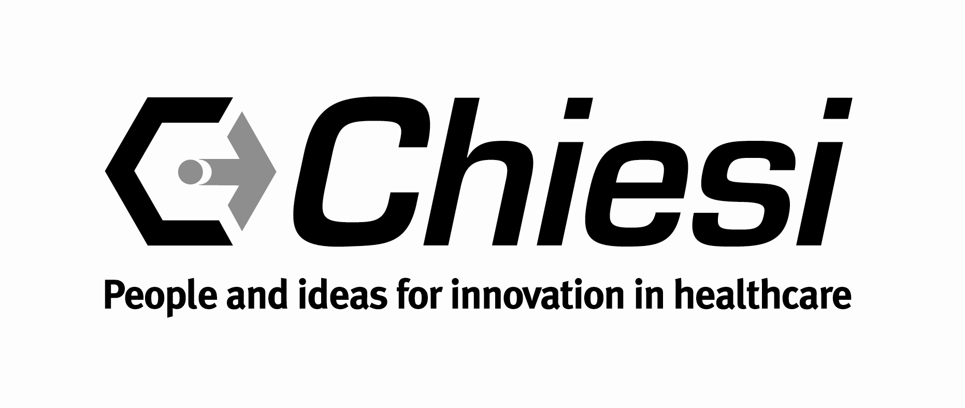
Since its foundation in 1995, under the name of Trinity Pharmaceuticals, Chiesi Limited set out to deliver value medicines to the NHS through its range of modified release preparations in the areas of cardiology, musculoskeletal and respiratory medicine.

In 1999 the company was acquired by the Chiesi Group, an international pharmaceutical company with headquarters in Italy. Since then Chiesi has expanded its portfolio to include medicines in the areas of neonatology, cardiovascular and gastrointestinal medicine. The Chiesi Group remains a family owned and managed business, having 3,737 employees operating in many countries across the globe.

Chiesi’s aim is to bring innovative solutions to their therapeutic areas of expertise, which include diseases such as cystic fibrosis and neonatal respiratory distress syndrome, as well as developing advanced drug delivery technologies.

In 2010 Chiesi received the R & D Award under the UK-Italy Business Awards programme for outstanding investments in R & D in the United Kingdom. In addition to its core Research and Development spend, in 2011 Chiesi opened a new €90 million R & D centre, hosting more than 300 employees, to add to its current research facilities across Europe and the USA.

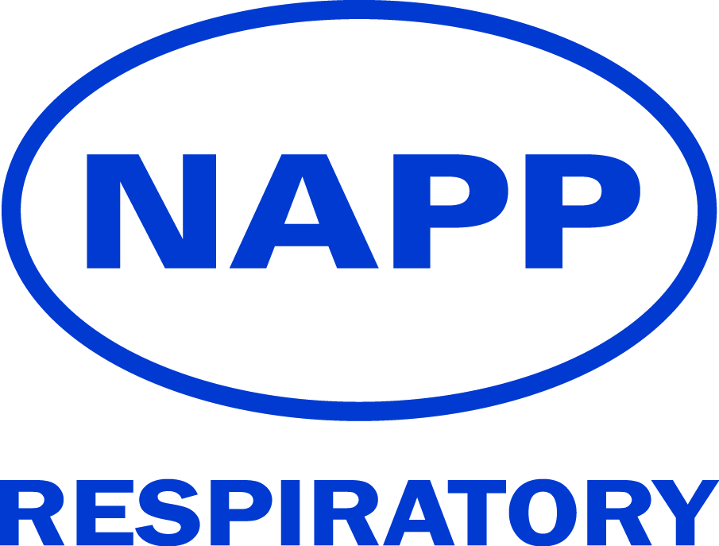

Napp Respiratory is a division of Napp Pharmaceuticals Limited, a successful and growing UK healthcare company with a strong track record in delivering medicines for long-term conditions. We provide high quality asthma medicines to the NHS that meet genuine needs, make a positive difference to patients and are appropriate for today’s cost-constrained healthcare environment. We support delivery of real world evidence and education to help healthcare professionals provide better asthma care. Our collaborative approach enables us to create long lasting partnerships with NHS organisations to improve asthma outcomes.

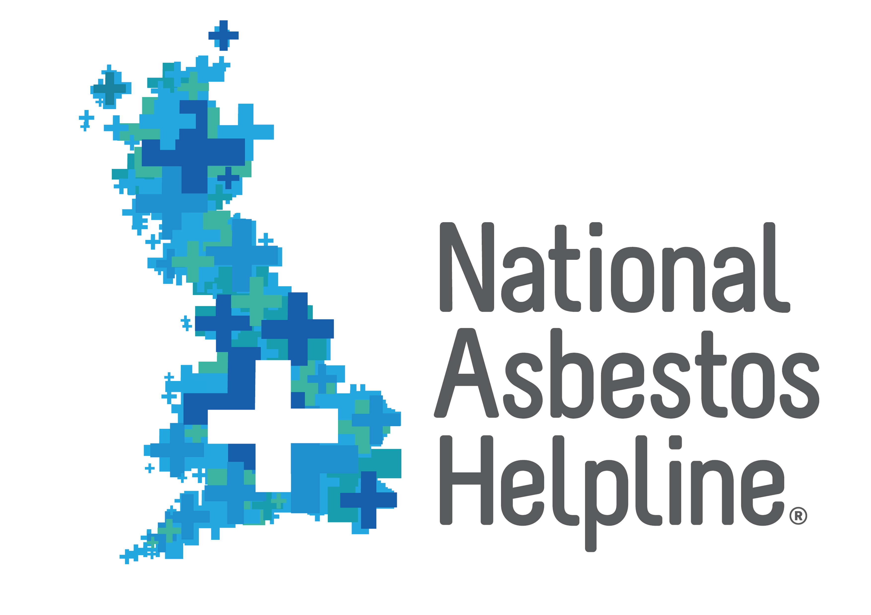

The National Asbestos Helpline has provided help and support to asbestos victims and their families for more than a decade. Asbestos is the UK’s biggest workplace killer and the Helpline receives more than 4,000 calls a year. The service is provided by Birchall Blackburn Law and the Helpline team directly helps callers with benefits, civil claims, practical advice and campaigns on behalf of asbestos victims. The specialist team also continues to raise awareness of the dangers of asbestos and provides education to medical professionals about asbestos-related diseases, symptoms and who is most at risk. For more information go to www.nationalasbestos.co.uk or call Freephone on 0800 083 0411.



Nutricia Advanced Medical Nutrition specialises in the delivery of medical nutrition products and services for all who need it, spanning from the very young to the elderly. We supply high quality feeds, equipment and support services to patients and healthcare professionals.
For more information please visit https://www.nutricia.co.uk/fortisip/



At Pfizer, we apply science and our global resources to improve health and well-being at every stage of life. We strive to set the standard for quality, safety and value in the discovery, development and manufacturing of medicines. Our diversified global healthcare portfolio includes biologic and small molecule medicines and vaccines, as well as many of the world’s best-known consumer products. Every day, Pfizer colleagues work to advance wellness, prevention, treatments and cures that challenge the most feared diseases of our time. For more than 150 years, Pfizer has worked to make a difference for all who rely on us
Exhibitors


Airsonett AB is a Swedish born company. Airsonett® offers Temperature controlled Laminar Airflow (TLA) technology, protecting patients from the exposure to allergens, spores, bacteria, viruses and other airborne particulates. Positioned at the bedside, it draws air through a filter, capturing them and thus providing patients filtered air to breathe whilst sleeping.
Airsonett® is for adults and children with severe allergic asthma with poor disease control despite optimal drug therapy at Step 4 (BTS/SIGN) or above.
The device (CE marked; Class 1) is non-invasive and non-pharmacological. It has no side effects and is suitable for adults and children.


GSK is a science-led global healthcare company with a mission to help people to do more, feel better and live longer



Medical Developments UK (MDUK) is a subsidiary of Medical Developments International (MDI), a global manufacturer of unique and innovative healthcare products.MDUK is focused on high quality products that improve respiratory care. These include space chambers for the delivery of asthma and COPD medication, portable low-power consumption nebulisers and finger type pulse oximeters measuring SpO₂.The company’s products are available from most high street pharmacy chains.
Designed to deliver more medication to the lungs than pMDI alone, enabling patients with asthma and COPD to take control, the Space Chamber Plus® is the largest spacer available from Medical Developments.
- Cross Valve Technology™ is designed to provide low resistance, one-way flow during inhalation for improved drug delivery and ease of use.
- Antistatic chamber allows maximisation of aerosol medication suspension².
- Does not need priming and can be used straight out of the package.
- Transparent chamber allows clear visualisation of valve movement and enables direct confirmation of correct use by patients.
- Universal inhaler base fits most pressurised metered dose inhalers (pMDI).
- Multipurpose mouthpiece can be used with standard 22 mm OD mouthpiece fittings for the delivery of asthma and COPD medication.
- Compact size for convenient handling and storage in school bags, handbags and briefcases.
- Not made with natural rubber latex, BPA, PVC and phthalates.
- Can be boiled.
- Dishwasher Safe.
- pMDI can be stored in chamber body.
- For use as part of an asthma action plan.



Mylan ranks among the leading global generic and specialty pharmaceutical companies. Ranked number 4 in the UK generic prescription market, Mylan maintains one of the industry’s broadest and highest quality portfolios, with around 1,400 high quality generic, branded and over-the-counter products globally, covering most available dosage forms and a big range of therapeutic categories.
At Mylan we have one global quality standard in everything we do. Our internal teams conduct reviews of all products, start to finish. No matter where in the world they are made.



Orion is a Finnish born innovative European R&D based pharmaceuticals and diagnostics company with an emphasis on developing medicinal treatments and diagnostic tests for global markets. Orion develops, manufactures and markets human and veterinary pharmaceuticals and active pharmaceutical ingredients as well as diagnostic tests.

Orion carries out extensive research with a goal of introducing new treatments into global markets. The core therapy areas in Orion’s product and research strategy are central nervous system, oncology, critical care and respiratory medicines.
www.orionpharma.co.uk



PARI are proud to be a Platinum sponsor of ARNS, as both organisations share a vision of promoting excellence in practice within the respiratory nursing community.

As a leading manufacturer of nebuliser systems for over 100 years, PARI develop solutions for people suffering from respiratory diseases in the form of high-quality, reliable devices.

PARI’s latest innovation is the VELOX – a mobile nebuliser based on vibrating membrane technology - specifically designed for patients with COPD. Winner of a German Design Award in 2015, the VELOX offers class-leading performance.

As the first choice for clinical trials worldwide, PARI nebulisers represent the ‘Gold Standard’ in nebuliser therapy



PMD Solutions - RespiraSense is the world's first continuous and accurate respiratory sensor that uniquely measures the mechanics of respiration, providing medical staff the earliest signs of in-hospital patient deterioration from conditions such as respiratory compromise, increasing severity of sepsis, and oncoming cardiac arrest.

Website:http://www.pmd-solutions.com/
https://twitter.com/PMD_Respiratory



We invite you to visit the Vitalograph stand to take a look at our extensive range of handheld, PC-based and desktop spirometers. In addition to the Compact, Pneumotrac, In2itive, Micro, Alpha and Alpha Touch spirometers we offer a wide range of affordable, easy-to-use respiratory monitors and screeners. Our Spirotrac software combines the power of your PC, network and spirometer, with options including Bronchial Challenge, 12-lead ECG, Pulse Oximetry, 6 minute walk test, Blood pressure and the latest GLI equations. We also offer a broad range of great value consumables.

For half a century Vitalograph has been trusted by medical professionals to provide world- leading respiratory screening, diagnostic and monitoring devices. Since the early days of the wedge bellows through to the sophisticated clinical trials solutions and computerised systems we offer today Vitalograph continue to push back the boundaries of possibility in respiratory care.

Charity Exhibitors



About the British Lung Foundation

One in five of us has problems with our breathing. Millions more are at risk. We’re the only UK charity looking after the nation’s lungs. With your support, we’ll make sure that one day everyone breathes clean air with healthy lungs. For further information, please visit www.blf.org.uk. For help and support, call the BLF Helpline on 03000 030 555. To donate £5 to help the BLF fight lung disease, please text LUNGS to 70500.



Education for Health is a leading UK-based educational charity, working to transform the lives of people living with long term health conditions. We aim to support nurses and other healthcare professionals in advancing their professional development to enhance the quality of patient care. We offer a comprehensive range of clinically-led education and training for healthcare professionals, including free-to-access online resources, workshops and accredited modules. Our academic team are clinicians and experts in their subject areas who continue to work in practice, bringing a real-life vibrancy to all that we do.

www.educationforhealth.org
email:contact@educationforhealth.org
twitter: @edforhealth



We are a not-for-profit professional network dedicated to allied healthcare professionals who are working in the ILD field. We are the place where ILD professionals meet to share their knowledge and experience and our aim is to promote excellence in the delivery of patient care.

Our vision is to empower the ILD interdisciplinary team through education research and support in order to make a positive difference in the lives of patients with interstitial lung disease. With the advent of new anti fibrotic medications the landscape has changed and produced a need for further education and support.

The Network aims to become the gold standard of ILD practice through protocols, and by acting as a primary resource to healthcare professionals and the patients they serve. Our passion is to promote excellence through best practice for patients, this, we believe, will lead to improvements in care and outcomes for all.
We would be delighted to hear from interested health care practitioner’s working in the field of ILD who are interested in joining the network

Website www.ILD-INN.org.uk

Partners 2017



