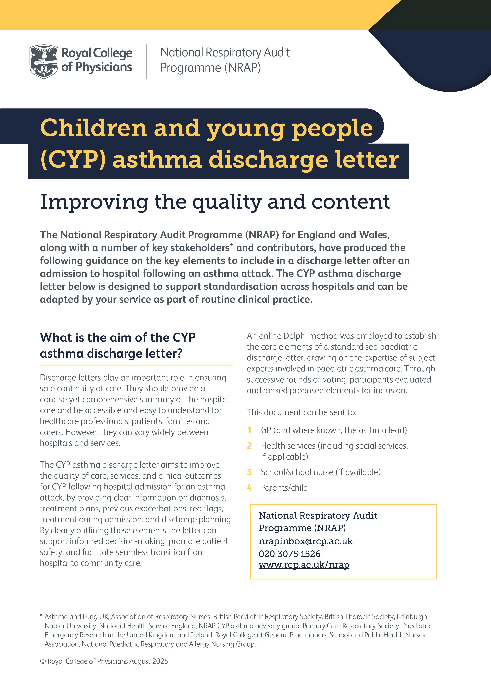
NRAP

CYP asthma discharge letter
Patient name:

Date of birth (dd/mm/year):

Date of admission:
Date of discharge:
Discharging ward:
Completed by:

1. Clear information for GP | (i) Clear statement of diagnosis | Diagnosis:  Code:
 | (ii) Severity of asthma attack | Mild / moderate / severe / life-threatening
 | (iii) Treatment plan | Include medication changes, trigger management
 | (iv) Post-discharge review | Responsible clinician/service:
 | (v) Regular follow-up plan | Named clinician/service:
2. Record of previous exacerbations | Especially within the previous year, any requiring IV treatment or any admission to critical care | Notes:
3. Red flags related to current episode | Which may relate to:  - medications  - poor symptom recognition  - lack of regular review  - environmental factors  - special needs/ other medical conditions (comorbidities)  - triggers | Notes:
4. Treatment during current admission | Including oxygen or IV therapy and/or admission to critical care | Notes:

National Respiratory Audit Programme (NRAP) | nrapinbox@rcp.ac.uk | 020 3075 1526 | NRAP webpage
5. Discharge planning | (i) Inhaler technique checked during hospital stay | □ Yes □ No
 | (ii) Asthma plan completed/checked | □ Yes □ No
 | (iii) Advice to families regarding post-admission period | □ Provided □ Not provided
Consider recording the results of relevant tests completed in hospital, eg blood tests / allergy testing / radiological tests / FeNO / PEF / spirometry |  | Blood tests / allergy testing / radiology / FeNO / PEF / spirometry – include values and dates

Last updated: September 2025

National Respiratory Audit Programme (NRAP) | nrapinbox@rcp.ac.uk | 020 3075 1526 | NRAP webpage

