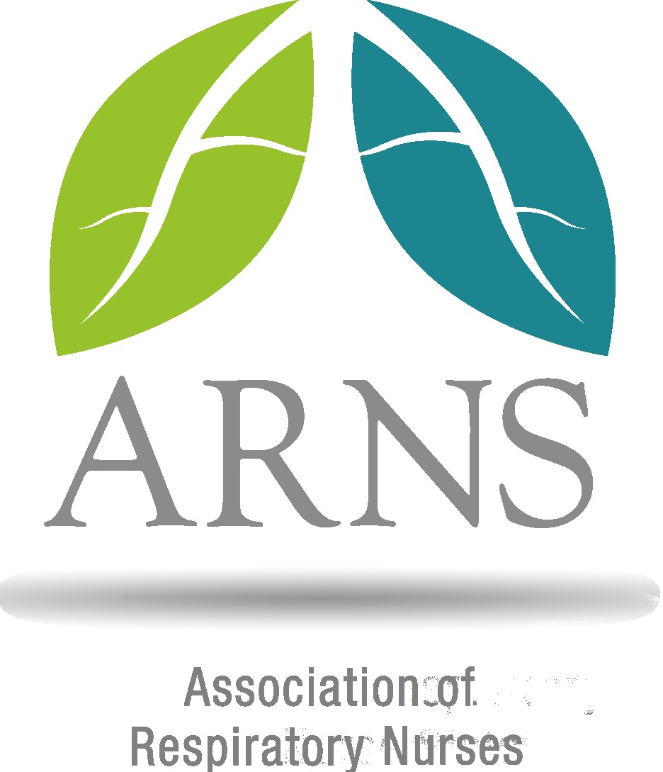

ASSOCIATION OF RESPIRATORY NURSES

ANNUAL GENERAL MEETING 2025
To be held during ARNS Conference

4:50pm, Thursday 15th May 2025
Deansgate Suite, Hilton Manchester Deansgate

AGENDA

- Welcome – Joanne King, Chair
Brief reflection on year so far
ARNS Conference locations 2026 and 2027
Introduction of Past Chair of ARNS role
Recruitment of Vice Chair-Elect role
Changes to Treasurer role
ARNS priorities for the next 12 months

- Introduction to the ARNS Board
- Thanks and farewell to
- Joanne King (Chair of ARNS)
- Sarah Kearney (ARNS Treasurer)
- Helen Morris
- Yvonne MacNicol
- Sara Mason
- Debbie Duncan
- Kerry Woodward
- Rachel Halliday
- Joanne Thompson

- Welcome to
- Helena Cummings (Research and Education SC)
- Jessica Mandizha (ILD Lead)
- Viv Marsh (CYP Lead)
- Respiratory Therapeutics Lead
- COPD Lead
- Acute Care Lead
- Pleural Lead
- Sleep and Ventilation Lead

- Treasurer’s Report – Sarah Kearney

- Education and Research update – Kate Lippiett
- Any other business

Next meeting date – May 2026, TBC

