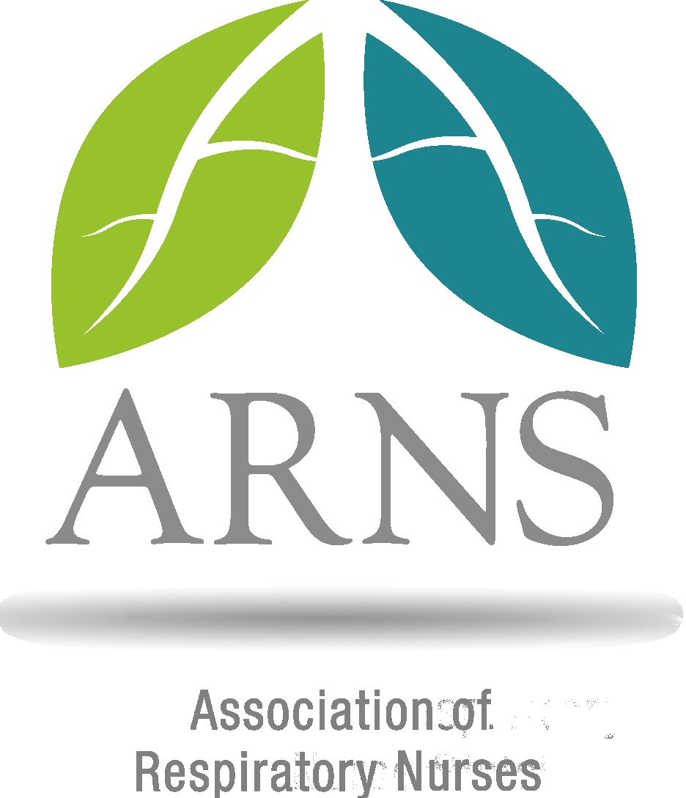

Please complete the Proxy Form below if you are unable to attend the AGM.

Association of Respiratory Nurses

PROXY FORM

I,……….......…..........………………………..of………………………...............……………………………

being a member of the above-named Company hereby appoint

....................................................................of...................................................

or failing him or her, the Chairman of the meeting as my proxy to vote for me on my behalf at the Annual General Meeting of the Company to be held on Thursday 16th May 2024 and any adjournment thereof

Signed………………………………… Name in capitals…………....……………..

Date:......................................................

Witnessed by

Signed………………………………… Name in capitals…………....……………..

Date:......................................................

Please note proxy forms must be received by ARNS Secretariat at least 48 hours before the AGM. Please email your completed form to info@arns.co.uk.

